**Title:** CLAMPS2 TROPoe Retrievals

**Authors:** Tyler Bell, OU-CIWRO/NSSL, tyler.bell@noaa.gov; Elizabeth Smith, NOAA/OAR/NSSL, elizabeth.smith@noaa.gov, Joshua Gebauer OU-CIWRO/NSSL, joshua.gebauer@noaa.gov

Data content questions can be directed to any author OR to the contacts listed at apps.nssl.noaa.gov/CLAMPS

**1.0 Dataset Overview**

These files contain 24 hour periods of retrieved thermodynamic profiles derived from observations collected by the CLAMPS2 Atmospheric Emitted Radiance Interferometer (AERI) and microwave radiometer (MWR). The TROPoe algorithm is a python equivalent to the AERIoe algorithm (see Turner and Loehnert, 2014; Turner and Blumberg 2019). These data were collected during the TRACER-CUBIC project. MWR only and combined AERI and MWR retrievals are available. **During this deployment the AERI had high noise so AERI only retrievals are unavailable and the combined AERI and MWR retrievals should be used with extreme caution.**

**1.1 Date range:** 25 May – 25 September 2022

**1.2 Location:** UH Coastal Center, La Marque, TX; 29.3861 N, 95.0421 W, 20 m elevation

**1.3 Estimated data availability**

**MWR-only retrievals**

**AERI and MWR combined retrievals**

**All data should be considered suspect.** These charts show data quality relative to the average data quality.

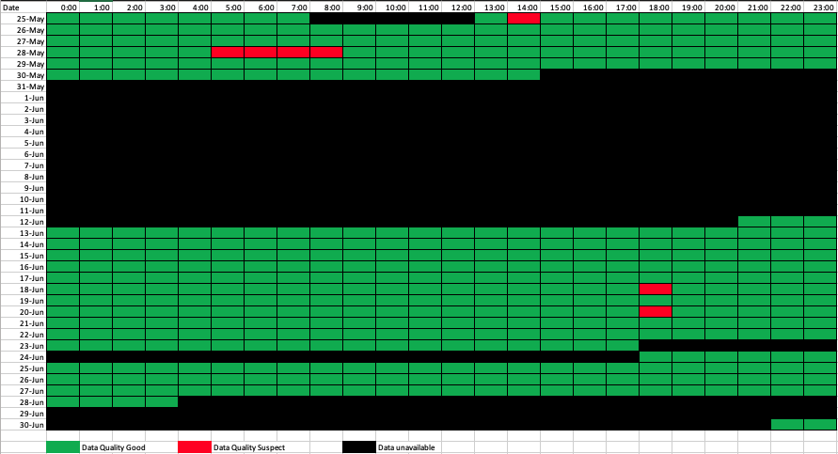

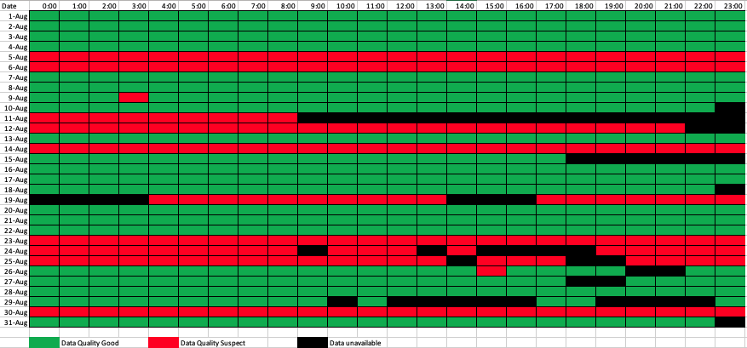

**2.0 Instrument Description**

The CLAMPS2 platform includes an ABB-AERI and RPG HATPRO MWR. The AERI consists of a Fourier transform interferometer, scene scanning-optics, IR detector, calibration blackbodies, and instrument control hardware. The exact system design and extensive theory of operation can be found in Knuteson et al. (2004). On a clear sky day it is capable of measuring IR radiances throughout the depth of the atmosphere with a wavenumber resolution 1 cm-1 and temporal resolution of ~20 seconds. The AERI has an absolute accuracy of < 1% of the ambient blackbody radiance and has typical noise < 0.2 mW (m2 sr cm-1)-1. The instrument is not able to collect observations in precipitation and when precipitation is detected a mechanical hatch is closed to protect the instrument. The radiances collected by the AERI contain information that can be used to obtain profiles of temperature, water vapor and trace gases as well as basic cloud properties. A MWR is a microwave receiver that measure the emission of microwave radiation from the atmosphere. The RPG HATPRO MWR observes microwave brightness temperatures in seven channels in the 22-31 GHz band and seven channels in the 51-58 GHz band. Information on the water vapor and integrated quantities of liquid water is in the 22-31 GHz band and temperature profile information is in the 51-58 GHz band.

**3.0 Data collection and processing:**

A climatology from soundings from Lake Charles, LA was used as the prior for the TROPoe retrievals. Recentering of this prior based on a surface water vapor measurement was performed for each retrieved profile. Zenith observations from all MWR channels are included in both sets of retrievals. In the combined AERI and MWR retrievals, radiances from the AERI in the following wavenumber bands were used: 538.0-588.0, 612.0-618.0, 624.0-660.0, 674.0-713.0, 713.0-722.0, 860.1-864.0, 872.2-877.5, 898.2-905.4 cm-1. Temperature and water vapor observations from a surface station and RAP analysis temperature and water vapor profiles above 4 km are also used in the retrievals. Cloud-based height information from a Doppler lidar was included for retrievals that occurred after 15Z on 24 June 2022. The retrieved profiles are available every 10 minutes.

**4.0 Data format:**

Data are provided in netcdf format. The typical naming convention is clamps*tropoe*C2.c1.YYYYMMDD.HHmmss.cdf, following closely to ARM file naming convention. Values in place of * are internal markers for version and platforms included in the retrieval. The files have time and height dimensions.

Variables provided (only listing selected basic variables, many more provided):

|  |  |  |
| --- | --- | --- |
| Name | Dimension | Unit |
| base_time | Single value | Seconds (since 00 UTC 1 Jan 1970) |
| time_offset | Time | Second (since base_time) |
| hour | Time | Hours since 00UTC this day |
| height | Height | km AGL |
| **temperature** | Time, Height | C, temperature |
| **waterVapor** | Time, Height | g/kg, water vapor mixing ratio |
| theta | Time, Height | K, potential temperature |
| Rh | Time, Height | %, relative humidity |
| dewpt | Time, Height | C, dew point temperature |
| thetae | Time, Height | K, equivalent potential temperature |
| sigma_* | Time, Height | m MSL, altitude above mean sea level |

Bolded variables are the main retrieved profiles from which other variables are derived. The sigma_* variables provide the 1-sigma uncertainty of that variable (available for main retrieved profile variables).

**5.0 Data Remarks**

The vertical resolution of the retrieved profiles decreases with altitude in both the MWR and AERI retrievals; this is due to the broadening of the weighting function as a function of height. Thus, there are relatively few independent pieces of information (IPI) in the profile (4-8 for the AERI, 2-4 for the MWR). However, the temporal resolution of the retrieved profiles from the AERI and MWR is high, and thus the evolution of the atmosphere, even with lower vertical resolution, can still be well characterized. It should be noted that the majority of the information on the temperature and humidity structure in the AERI and MWR observations is in the lowest 2-3 km; very little information exists above these levels in the observations due to the very broad weighting functions at those altitudes.

The two instruments also have a significantly different sensitivity to clouds. The optical depth of a cloud is much smaller in the microwave than in the infrared, and thus the retrieved temperature and humidity profiles from the MWR are much less sensitive to the presence of the cloud; this is not the case in the infrared where the emission from the cloud greatly hampers the ability to retrieve profiles from the AERI. Cloud base height is an essential input into the AERI retrieval algorithm in cloudy conditions; this can be easily determined from the Doppler lidar measurements. This complementary nature, the higher vertical resolution by the AERI in clear sky scenes but the “all weather” (with the exception of moderate to heavy precipitation) capability of the microwave profiler, is why we have included both systems in this facility.

**6.0 References**

Knuteson, R. O. and Coauthors, 2004: Atmospheric Emitted Radiance Interferometer. Part I: Instrument Design. *J. Atmos Oceanic Tech.*, **21**, 1763-1776.

Turner, D.D., and U. Loehnert, 2014: Information content and uncertainties in thermodynamic profiles and liquid cloud properties retrieved from the ground-based Atmospheric Emitted Radiance Interferometer (AERI*). J. Appl. Meteor. Clim.* **53**, 752-771, doi:10.1175/JAMC-D-13-0126.1*.*

Turner, D.D. and W.G. Blumberg, 2019: Improvements to the AERIoe thermodynamic profile retrieval algorithm. *IEEE Selected Topics Appl. Earth Obs. Remote Sens*., **12,** 1339-1354, doi:10.1109/JSTARS.2018.2874968.