**Title:** SPARC TROPoe Retrievals

**Authors:** Petra Klein, OU SoM, pkklein@ou.edu; Tyler Bell, OU-CIWRO/NSSL, tyler.bell@noaa.gov; Elizabeth Smith, NOAA/OAR/NSSL, elizabeth.smith@noaa.gov, Joshua Gebauer, OU-CIWRO/NSSL, joshua.gebauer@noaa.edu

Data content questions can be directed to any author or at https://www.ssec.wisc.edu/sparc/

**1.0 Dataset Overview**

These files contain 24 hour periods of retrieved thermodynamic profiles derived from observations collected by the University of Wisconsin–Madison Space Science and Engineering Center Portable Atmospheric Research Center (SPARC) Atmospheric Emitted Radiance Interferometer (AERI). The TROPoe algorithm is a python equivalent to the AERIoe algorithm (see Turner and Loehnert, 2014; Turner and Blumberg 2019). These data were collected during the TRACER project.

**1.1 Date range:** 12 June – 23 September 2022

**1.2 Location:** Aldine, TX; 29.9011 N, 95.3262 W, 25 m elevation

**1.3 Estimated data availability**

**

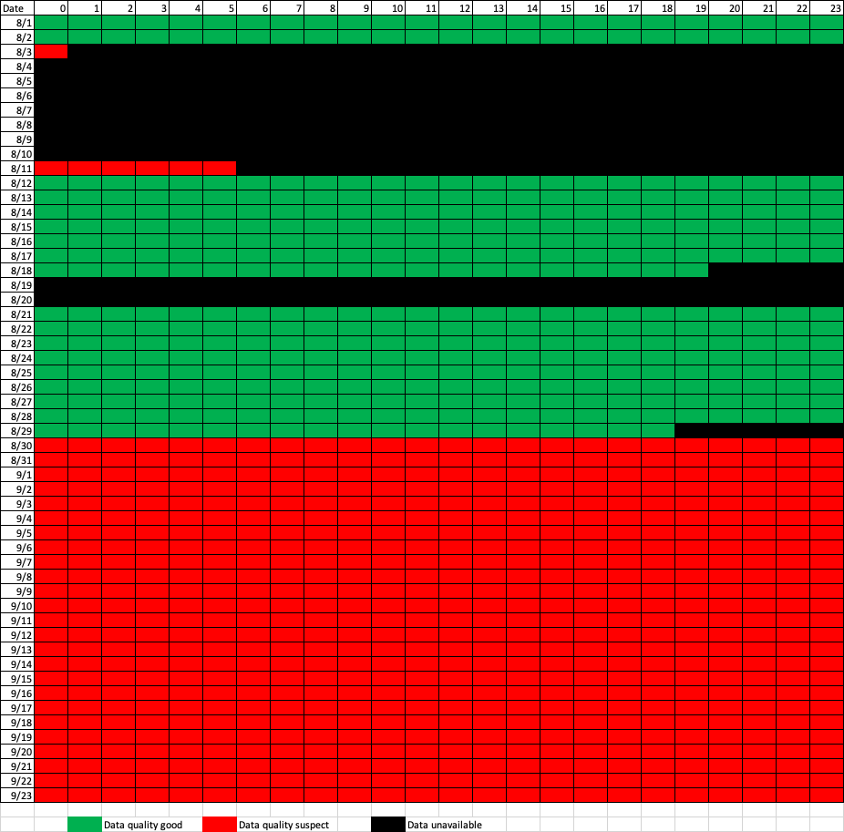

**2.0 Instrument Description**

The AERI consists of a Fourier transform interferometer, scene scanning-optics, IR detector, calibration blackbodies, and instrument control hardware. The exact system design and extensive theory of operation can be found in Knuteson et al. (2004). On a clear sky day it is capable of measuring IR radiances throughout the depth of the atmosphere with a wavenumber resolution 1 cm-1 and temporal resolution of ~20 seconds. The AERI has an absolute accuracy of < 1% of the ambient blackbody radiance and has typical noise < 0.2 mW (m2 sr cm-1)-1. The instrument is not able to collect observations in precipitation and when precipitation is detected a mechanical hatch is closed to protect the instrument. The radiances collected by the AERI contain information that can be used to obtain profiles of temperature, water vapor and trace gases as well as basic cloud properties.

**3.0 Data collection and processing:**

A climatology from soundings from Lake Charles, LA was used as the prior for the TROPoe retrievals. Recentering of this prior based on a surface water vapor measurement was performed for each retrieved profile. Radiances from the AERI in the following wavenumber bands were used in the retrievals: 538.0-588.0, 612.0-618.0, 624.0-660.0, 674.0-713.0, 713.0-722.0, 860.1-864.0, 872.2-877.5, 898.2-905.4 cm-1. Temperature and water vapor observations from a surface station and RAP analysis temperature and water vapor profiles above 4 km are also used in the retrievals. Cloud-based height information from a Doppler lidar was included as well. The retrieved profiles are available every 10 minutes.

**4.0 Data format:**

Data are provided in netcdf format. The typical naming convention is sparctropoe10.aeri.v2.C1.c1.YYYYMMDD.HHmmss.nc, following closely to ARM file naming convention. Values in place of * are internal markers for version and platforms included in the retrieval. The files have time and height dimensions.

Variables provided (only listing selected basic variables, many more provided):

|  |  |  |
| --- | --- | --- |
| Name | Dimension | Unit |
| base_time | Single value | Seconds (since 00 UTC 1 Jan 1970) |
| time_offset | Time | Second (since base_time) |
| hour | Time | Hours since 00UTC this day |
| height | Height | km AGL |
| **temperature** | Time, Height | C, temperature |
| **waterVapor** | Time, Height | g/kg, water vapor mixing ratio |
| theta | Time, Height | K, potential temperature |
| Rh | Time, Height | %, relative humidity |
| dewpt | Time, Height | C, dew point temperature |
| thetae | Time, Height | K, equivalent potential temperature |
| sigma_* | Time, Height | m MSL, altitude above mean sea level |

Bolded variables are the main retrieved profiles from which other variables are derived. The sigma_* variables provide the 1-sigma uncertainty of that variable (available for main retrieved profile variables).

**5.0 Data Remarks**

The vertical resolution of the retrieved profiles decreases with altitude in AERI retrievals; this is due to the broadening of the weighting function as a function of height. Thus, there are relatively few independent pieces of information (IPI) in the profile from the AERI (~4-8). However, the temporal resolution of the retrieved profiles from the AERI and MWR is high, and thus the evolution of the atmosphere, even with lower vertical resolution, can still be well characterized. It should be noted that most of the information on the temperature and humidity structure in the AERI observations is in the lowest 2-3 km; very little information exists above these levels in the observations due to the very broad weighting functions at those altitudes.

The AERI also has a significant sensitivity to clouds. Emission from the cloud greatly hampers the ability to retrieve profiles from the AERI above the cloud base height. TROPoe does account for radiances from cloud base, but an observation of the cloud base height is needed for this to be done properly. Cloud base height can be easily determined from the SPARC Doppler lidar measurements and those observed cloud-based heights are used in the retrieval. In situations where clouds are present, retrieved quantities above the cloud base should be used with caution and in most cases should be disregarded.

**6.0 References**

Knuteson, R. O. and Coauthors, 2004: Atmospheric Emitted Radiance Interferometer. Part I: Instrument Design. *J. Atmos Oceanic Tech.*, **21**, 1763-1776.

Turner, D.D., and U. Loehnert, 2014: Information content and uncertainties in thermodynamic profiles and liquid cloud properties retrieved from the ground-based Atmospheric Emitted Radiance Interferometer (AERI*). J. Appl. Meteor. Clim.* **53**, 752-771, doi:10.1175/JAMC-D-13-0126.1*.*

Turner, D.D. and W.G. Blumberg, 2019: Improvements to the AERIoe thermodynamic profile retrieval algorithm. *IEEE Selected Topics Appl. Earth Obs. Remote Sens*., **12,** 1339-1354, doi:10.1109/JSTARS.2018.2874968.